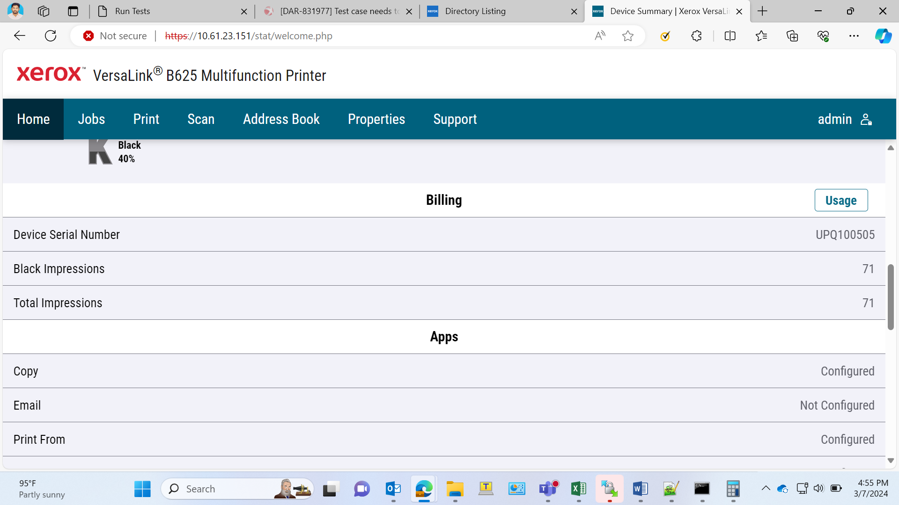

Log Identifier
UPQ100505.20240307.A002

Log Identifier
UPQ100505.20240307.B001

